**Task 2**

**Execute the following network commands like ipconfig, tracert, telnet, netsh, ping, nslookup, netstat**

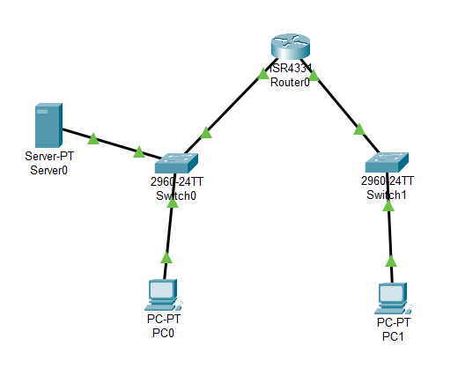

**Step 1:** Launch Cisco Packet Tracer

Double-click the Cisco Packet Tracer icon on your desktop or find it in your applications list and open the program.

**Step 2:** Create a simple network topology

**1. Add devices**

Routers and Switches

Drag and drop a router and a switch from the device list onto the workspace

PC’s

Drag and drop 2 PC’s onto the workspace

**2. Connect devices**

Use the connection tool to connect the devices

Connect 1st PC to the switch using the Copper Straight-Through cable

Connect the switch to the router using another Copper Straight-Through cable

Connect the 2nd PC to the switch using a Copper Straight-Through cable

// Connect the switch to the router using another Copper Straight-Through cable

**3. Configure devices**

Configure the router

Click on the router, go to the config tab, and assign IP addresses to the router interfaces

**Ex:** PC0: Interface G0/0: IP address 192.168.1.1

Subnet Mask: 255.255.255.0

**Ex:** PC0: Interface G0/0: IP address 192.168.2.1

Subnet Mask: 255.255.255.0

Configure the PC’s

Click on each PC, go to the desktop option, and then IP configuration

Assign IP addresses to each PC

**Ex:** PC0: IP address 192.168.1.2

Subnet Mask: 255.255.255.0

Default Gateway: 192.168.1.1

**Ex:** PC1: IP address 192.168.2.2

Subnet Mask: 255.255.255.0

Default Gateway: 192.168.2.1

**4. Execute networking commands**

* Click on a PC0
* Go to the **Desktop** tab and open the **Command Prompt**

**1. ipconfig:**

This command displays all current TCP/IP network configuration values and refreshes DHCP and DNS settings.

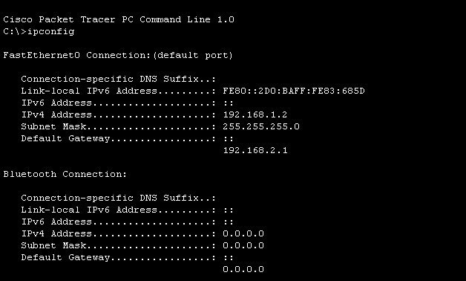

**2. tracert:**

This command traces the path taken to a destination by sending ICMP Echo Request messages.

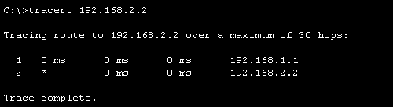

**3. telnet:**

This command is used for interactive communication with another host using the Telnet protocol.

telnet <destination IP> <port>

1. **Assign IP Address:**

* Click on the router.
* Go to the **Config** tab
* Select the interface connected to the switch (eg, G0/0)
* Assign IP address: 192.168.1.1, Subnet Mask: 255.255.255.0

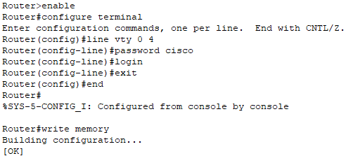

**Telnet from PC to Router**

1. **Open Command Prompt:**

* On the PC0, go to the **Desktop** tab and open the **Command Prompt**.

1. **Execute Telnet Command:**

**telnet <destination IP> <port>**

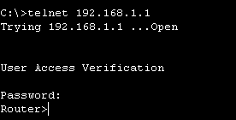

**4. Router configuration and Brief IP interface**

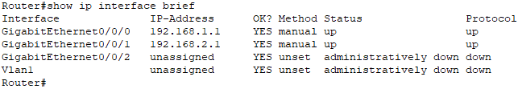

**5. Ping 192.168.2.2**

**ICMP Echo**

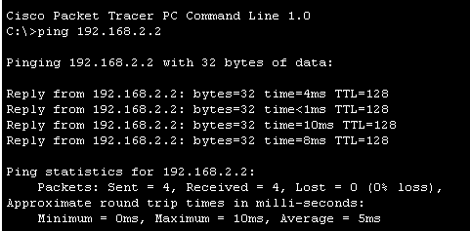

**6. nslookup**

**nslookup** [**www.google.com**](http://www.google.com)

**Configure the DNS Server**

1. **Assign IP Address:**

* Click on the server.
* Go to the **Config** tab and select the **FastEthernet0** interface.
* Assign IP address: 192.168.1.3, Subnet Mask: 255.255.255.0, Default Gateway: 192.168.1.1

**Configure DNS Server**

* Go to the **Services** tab on the server.
* Select **DNS** and turn the service **on**.
* Add an entry for [www.google.com](http://www.google.com) with an IP address (e.g., 8.8.8.8)

**Use the nslookup Command**

1. **Open Command Prompt on PC0:**

Go to the **Desktop** tab on PC0.

Open the **Command Prompt.**

1. **Execute the** nslookup **Command:**
2. **nslookup** [**www.google.com**](http://www.google.com)

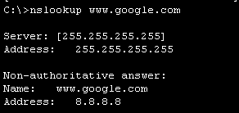

**7. Netstat**

